**ICICC-2023**



**6th International Conference on Innovative Computing and Communication**

Organized by Shaheed Sukhdev College of Business Studies, New Delhi, India

On 17-18th FEBRUARY 2023.

**\*\*\*\*\*\*\*\*\*\*\*\*\*\* CALL FOR PAPERS \*\*\*\*\*\*\*\*\*\*\*\*\*\*\***

**SPECIAL SESSION ON**

Emerging Trends, Issues, and Challenges in Artificial Intelligence, Internet of Things and Cloud Computing

**SESSION ORGANIZERS:**

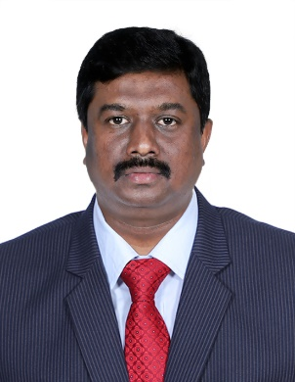**Dr.S.Balakrishnan**

**Professor and Head,**

**Department of Computer Science and Business Systems,**

**Sri Krishna College of Engineering and Technology,**

**Coimbatore, Tamilnadu, India. 641008**

[balkiparu@gmail.com](mailto:balkiparu@gmail.com)

**7550244766**

**EDITORIAL BOARD: (Optional)**

**[Name, University or Organization, Country, e-mail]**

**SESSION DESCRIPTION:**

Artificial Intelligence Applications in Agriculture, Industry, Health, Business, Food, Energy, Materials, Education, Social, Statistics, Architecture, Mathematics, Natural Sciences and other fields, Analytical Management and Information System, Fundamentals of Machine Learning in Artificial Intelligence, IoT and cloud computing technologies.

**RECOMMENDED TOPICS:**

Topics to be discussed in this special session include (but are not limited to) the following:

* **AI application in Health**
* **AI application in agriculture**
* **IoT application in agriculture**
* **IoT application in Health care**
* **Cloud Computing technologies**
* **Iot and AI application in Natural sciences**

**SUBMISSION PROCEDURE:**

Researchers and practitioners are invited to submit papers for this special theme session on **[session name] *on or before* [30th October 2022]**. All submissions must be original and may not be under review by another publication. INTERESTED AUTHORS SHOULD CONSULT THE CONFERENCE’S GUIDELINES FOR MANUSCRIPT SUBMISSIONS at <http://icicc-conf.com/paper_submission.html>. All submitted papers will be reviewed on a double-blind, peer review basis.

**NOTE:** While submitting paper in this special session, please specify [**Session Name**] at the top (above paper title) of the first page of your paper.

**\* * * * * \***